Into the Silence:

An Exploration of

Inner Terrain

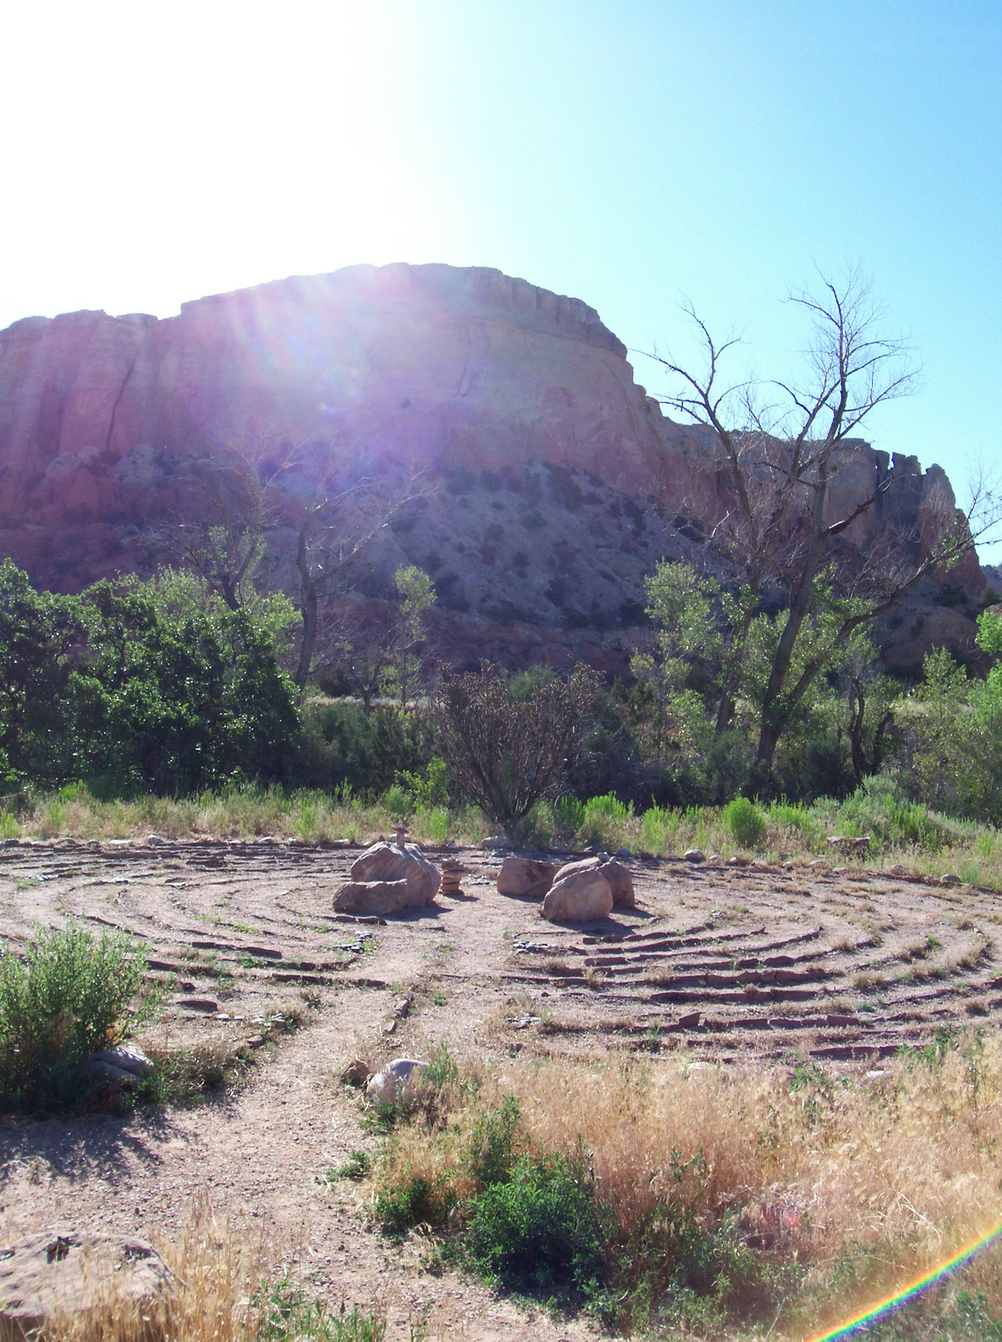

Friday Evening October 15 to Monday noon October 18, 2010
Santa Fe Campus of Ghost Ranch, New Mexico

We come from a great Silence and we return to a great Silence. In the interval we call Life, Silence can be our most helpful companion, coaxing us to hear the Wise One Within (WOW!). When we travel in Silence through our inner terrain, we can find important clues to the life we truly want.

This workshop combines poetry writing, visual art, and meditation in unique ways to make personal wisdom available. The culminating project of the weekend is a small handmade book containing poetic and visual insights from the journey into silence.

In our time together we’ll learn practical meditation, writing, and art techniques. We will have a chance to uncover profound gifts in our own life events and uncover surprising future paths and choices!
Schedule:
Friday evening – 6 PM Dinner and Orientation
Saturday – Class 9AM to Noon – Museum Tours – Evening Class 7-9PM
Sunday – Class 9AM to Noon – Museum Tours – Evening Class 7-9 PM
Monday – 9-11AM Celebration and Intentions
* * * * *
Your facilitator is Patricia Webb, creative writer and Oklahoma Artist-in-Residence. In 1997 she went “into Silence” to renew her life’s purpose. Pat has conducted hundreds of Silence Workshops throughout the U.S. and Canada. Pat's unusual art, journaling, and mindfulness exercises help people of all ages walk their inner terrain and hear their inner voice. She is co-founder of The Silence Foundation, a non-profit organization based in Oklahoma City.

Her co-facilitator is Jan Sanders, founder of PEOPLEnergy, Toronto, Canada. Jan has studied with Mystery School and Social Artistry pioneer Jean Houston and designed programs in wholistic community development, including global assignments with the United Nations. Jan enjoys watercolor arts, drumming, and connecting with nature in mindful awareness.

Fee: Prior to August 15th - $395 after Aug. 15th - $495
Includes 3 nights Lodging, Meals, and all Class Sessions
Limited to 12 Persons so please register soon
Please check online at www.ghostranch.org – Class S10S103 or
Call our registrar, Sue Lundstrom 1-800-821-5145 (x223)
Questions? Call Pat Webb (405)209-7117

