Social Process

By Jon C. Jenkins

The social processes is a model delineating the dynamics of any social unit. They were developed in preparation for a Research Assembly put on by the Ecumenical Institute in Chicago, Illinois in 1971. Approximately 1500 people attend the Assembly to discern the major social issues facing the world today.

In the Fall of 1970 a project was initiated to begin the process of developing the triangles. The project was called the Corporate Research Reading Project and more than 25 locations some 1500 books were read and reported to a team based in Chicago. While the team varied in size over the next 9 months or so a core of about 25 people worked on the social processes.

The Purpose
Why would some much energy go into such a project? Why develop a diagnostic tool such as the Social Processes? First they were developed to deepen the institutes appreciation of how societies function. They wanted to be able to spot trends and changes in a variety of social units. They wanted to be able to analyse social problems and issue and to discern opportunities for change.

As the processes developed and were applied they also began to be used as a way of discerning imbalances. They also became a tool for appraising the climate for business and for assessing the capability of organisations to respond to changing climates.

Social Process Rationale
Several values were being held as the triangles were developed.
- They were to be comprehensive, that is they were to deal with all aspects of society. And while this value was very important it is clear that at the lower levels of the triangles things were missed.
- Second they were to be Universal in the sense that the model should work for every society and at every level of society. Checks were made to see if the processes were usable across time. Historical documents were reviewed. Anthological ethnographies were read and the processes checked for usefulness.
- Third it was to be an analytical tool. Could it be used to detect important patterns in society?
- Fourth, it was to be relational. A set of triangles was used to keep the processes simple and capable of being increasingly complex. This also helped it to be memorable.
- Last it was to be dynamic and not institutional. This allows the user to go beyond the social structures and ask how is this dynamic present besides the institutions say of education or law.

Major Components

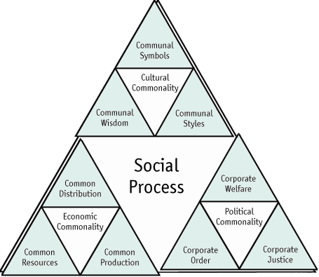

Social Process Triangles
Economic Commonality is the foundational dynamic which provides the means of living for society. This dynamic is made up of 3 sub dynamics, Common Resources, Common Production and Common Distribution.

Political Commonality is the process of bringing organization to a social unit. Political commonality is made up of the three dynamics of Corporate Order, Corporate Justice and Corporate Welfare

Cultural Commonality is the dynamics of meaning giving in a society. It is made up of the dynamics of Communal Wisdom, Communal Style and Communal Symbols.

Each subset of triangles is made up 3 sub sub triangles. The level of Economic, Political and Cultural is considered level one. The level that includes resources, production and distribution and so forth is called level 2. There are 6 levels for the social process. For practical purposes level three is the deepest level that is used in most applications.

The social processes can be seen as a fractile in which the same pattern is repeated at every level. Each triangle is made up of three poles, a foundational pole, an organising pole and a meaning-giving pole. They are respectfully the lower left, lower right and top.

The multiple levels of the triangles enable the user to focus at the most useful level for the work that they are doing. It also allows the user to do a multi-level analysis. More depth and nuance is revealed by this aspect of the triangles.

Complementary Dynamics

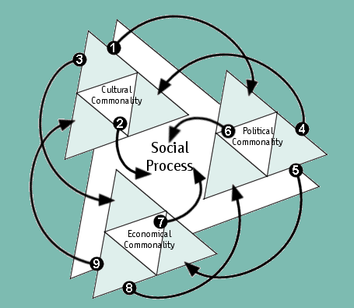
Social Dynamics

- Gives governing assumptions direction
- Develops and maintains social values and norms
- Determines business preferences
- Protects and structures
- Determines rules of conduct
- Organises and Governs the interaction of society
- Sustains and nurtures the social fabric
- Supplies public infrastructure
- Provides the means for realising

Each of the dynamics interacts with the other dynamics and with the whole dynamic of which it is a part. In the diagram above Cultural Commonality (1) effects Political Commonality by giving direction to the governing assumptions, (2) effects the Social Processes as a whole by developing and maintaining social values and norms, and (3) effects Economic Commonality by determining business preferences.

These complementary dynamics reflect the holistic functioning of society, the interdependence of every aspect of society and the multiple perspectives from which to view any event.

The Uses of The Social Process
The social processes are used in a wide variety of ways. I will only illustrate a few of these ways. During the Summer Research Assembly two of these methods were developed, as a diagnostic screen and as a way of discerning imbalances in society.

The first is to use the social processes as a screen through which to view social issues. In the assembly, teams were assigned to specific triangles. They were to determine the issues society faces in that social arena. In community workshops the same process has been used where 3 or 4 people would be assigned to each of the level 2 triangles (Resources, Production and Distribution) to first determine how that dynamic worked in the community and then to discern issues the community faced in that process.

The second method developed in the Summer Research Assembly became know as the Social Imbalances.

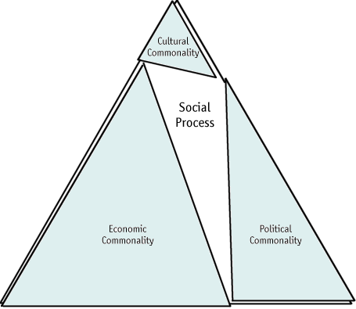

In the process of looking at the dynamics of society the research team came upon the idea that at any moment of time the social processes were in some way imbalanced. The above diagram reflects today’s society. Economic values and considerations dominate the whole social fabric. The political processes are an ally of the Economic. The Cultural processes have collapsed. While this is in constant flux and motion, these basic insight seem to still be true.

In the middle ages in Europe the dominate dynamic at this level was the cultural process – the church dominated society. The political processes were the ally and the economic was collapsed.

Since the Summer Research Assembly several uses have developed. They have be used to determine the multiple roots of social issues such as illegal use of drugs or the tensions around abortion and euthanasia. In each of these examples different dynamics play different roles and are emphasised by different proponents. In the case of illegal drug use in the USA, the most obvious arguments centre around law and order (the lower left of Political Commonality), Supply and Demand (the top of Economic Commonality) and life style choice (the lower right of Cultural Commonality). This would seem to suggest that any solution that is developed must address all of these dynamics.

Other uses include using the social processes as a supplement to a standard SWOT analysis. They have been used to determine leverage points to accelerate social or organisational change.

They are used for trend analysis’s. The trends analysis is done in the following way.
- Using the Social Processes do determine the present profile of the organisation (community, industry, society, etc.)
- Identify trends that are emerging, mature or counter trends.
- Assess the impacts of the trends for some future period.
  - Strength of Trend (take into account the counter trends)
  - Likely Impact of the Trend (also take into account the counter trends)

Low - Likely Impact - High | Monitory | Critical
Low - Likely Impact - High | Ignore | Monitory
 | <- Low – Strength of Trend – High ->
4. Determine the appropriate response.

Conclusion
This paper is intended as an introduction to The Social Process Triangles. A more extended description is available in paper and CD-ROM format (see www.imaginal.nl or www.icacan.ca). While this diagnostic model has be around for some time, it is little used because of its inaccessibility. With the development of the WWW perhaps now is the time for such a tool.

The most insightful overview of the origin and use of the Social Processes is found at the Union of International Associations (see http://www.uia.org/strategy/90icaall.htm) Actually the whole site is a wonderful collection of great ideas.

Courses using the Social Processes can be found at the ICA Canada (see http://www.icacan.ca/courses.cfm). The University of Maryland University College’s on-line Masters in International Management teaches the use of a variation of the Social Processes called The Corporate Processes (see http://www.umuc.edu/).

Finally, I would like to thank Dr. Clarence Mann, Dean of Masters of International Management Program at the University of Maryland University College for his work in using The Social Processes and the opportunity to work with him in presenting The Social Processes at the International Association of Facilitator’s 2000 Conference in Toronto. Also of great help were Pricilla Wilson of Team Tech in Kansas City, Kansas and Jo Nelson with the ICA Canada.

